

Project Specification

|  |  |
| --- | --- |
| Project Number: | CS-16-3-01 |
| Project Name: | Acuity STAR Computer Science Dashboard |
| Current Phase: | Phase II |

|  |  |
| --- | --- |
| Prepared by: | Derrick Gould |
| Date Issued | September 26, 2016 |
| Version: | 1.0 |

**Document History**

| *Version* | *Date* | *Author/Editor* | *Comments* |
| --- | --- | --- | --- |
| 0.91 | September 21, 2016 | Derrick Gould | Initial Draft |
| 1.00 | September 26, 2016 | Derrick Gould | Final Release |
|  |  |  |  |
|  |  |  |  |
|  |  |  |  |
|  |  |  |  |
|  |  |  |  |
|  |  |  |  |

Table of Contents

Project Specification 4

Scope Inclusion 5

Scope Exclusions 5

Project Strategy 5

Assumptions & Constraints 6

Assumptions 6

Constraints 6

Appendix A – What is Acuity STAR? 7

Appendix B – Our Customers 8

Clinical Academic Departments / Basic Science Departments 8

Appendix C – STAR Pages and Data Points 9

Data Files and Fields 9

Appendix D – Phase I Project 10

Screenshots from Peach Galaxy 10

Screenshots from Acuity STAR 10

Project Specification

This is a collaborative project between Schulich School of Medicine & Dentistry Information Services Department and Western Computer Science.

For this project, teams of students will be provided with a full Dashboard Phase I application, including code, flowcharting, documentation, install files, executables, and all source files.

*New Requirements for Phase II:*

1. Add the ability to be able to sort department members by division
2. Add the ability to be able to sort department members by custom list

*Additional Project Deliverables:*

**Milestone 1**

1. A submission showing the detailed analysis of the Phase I project submission.
2. A proposal stating the 3 major improvements that the Phase II project team will implement in the allotted time.
3. A prototype or visual representation of the planned improvements

**Milestone 2**

1. A refined submission detailing the expected final submission, and all components that will be submitted.
2. A working draft of the program with some working functionality, and placeholders to any not yet working functionality.
3. Initial draft of documentation & project status report.

**Final Submission**

1. Fully functional, error free program which includes the original functionality, and incorporates the new requirements A & B above, as well as the 3 improvements each team has made to the original program.
2. All program source code, documentation, and project files
3. Executable file, support files & installation file.
4. Summary of Lessons Learned.

## Scope Inclusion

Take an existing Computer Science Phase I Dashboard Project which loads, sorts, and reports on 4 defined areas of Acuity STAR data which has been exported in Excel (XLS) format.

Teams will take the 4 supplied XLS files, import the records, parse the records, and display records in an intuitive user interface. Charting and reporting is also a requirement, including displaying the charts in the interface and in PDF output.

1. The 4 academic activities tracked include:
   * 1. Program Teaching (7 data points)
     2. Presentations (7 data points)
     3. Publications (6 data points)
     4. Grants/Clinical Funding (10 data points)

## Scope Exclusions

1. Any programmatic changes to the Acuity STAR Application, functions or features
2. The need to access Acuity STAR data.

Project Strategy

* An initial set of meetings to introduce students to Acuity STAR
* Provide background on STAR and the need for this development project.
* Regular meetings to review progress and answer questions.

# Assumptions & Constraints

## Assumptions

* There is a fundamental assumption that Acuity will not legally object with any work being performed.
* Each student group involved with this project will adhere to a confidentiality agreement
* Each student group involved will have access to appropriate software to develop a solution.

## Constraints

* No attempts to decompile any code (the intellectual property of Sienex / Acuity Software Inc).
* Students should have their own sandbox working environment and not need to access the STAR site.
* Students will not contact Acuity Inc. If questions arise that cannot be directly answered by the Western ATG team, the ATG team will be the interface between students and Acuity.
* This project should not cause any outage or performance impacts to both the production and staging Acuity STAR application sites.
* This project should be completed in the timeframe for the CS student coursework.
* Any solution should be able to work within Schulich IS standard technology.  
  SQL Server 2012, IIS, .NET or PHP, Windows Server 2008
* All coding done for this project will be in C++ unless otherwise approved by your professor or TA’s

# Appendix A – Acuity STAR

## What is Acuity STAR?

* Acuity STAR is an online Secure Web Database, hosted within the Schulich School of medicine & dentistry Information Services infrastructure.
* Acuity STAR has a very simple user interface to add / edit / delete activity records within the database.
* Acuity STAR tracks Faculty Member: Personal Data, Teaching Data, Research Data, and Administrative data, all of which together are combined to create an RTF Faculty Member CV document, generated by STAR.

## Which areas of Acuity STAR are in scope?

* Teaching Activities | Program Teaching
* Research & Scholarly Activities | Presentations (7 data points)
* Research & Scholarly Activities | Publications (6 data points)
* Research & Scholarly Activities | Grants/Clinical Funding (10 data points)

## Which areas of Acuity STAR are NOT in scope?

* All STAR pages not named above are out of scope for this project.

# Appendix B – Our Customers

***Schulich School of Medicine & Dentistry - Clinical Faculty Departments:***

|  |  |
| --- | --- |
|  | Anesthesia & Perioperative Medicine |
|  | Clinical Neurological Sciences |
|  | Family Medicine |
|  | Medical Imaging |
|  | Medicine |
|  | Obstetrics & Gynecology |
|  | Oncology |
|  | Ophthalmology |
|  | Otolaryngology - Head & Neck Surgery |
|  | Paediatrics |
|  | Pathology & Laboratory Medicine |
|  | Physical Medicine & Rehabilitation |
|  | Psychiatry |
|  | Surgery |

The Schulich School of Medicine & Dentistry has two distinct faculty areas. One area comprises the Basic Science Departments, and the other comprises the Clinical Academic Departments.

Basic Science Department members and Clinical Academic members both share the responsibilities to Teach in the Schulich School of Medicine & Dentistry, and also conduct research with grants from various external and internal sources.

Clinical Academic Faculty Members differ from Basic Science Faculty members in that they also have a clinical medical practice along with their teaching and research responsibilities.

For the purposes of this course, we are only working with the 14 Clinical Academic Faculty Departments.

Some of the Clinical Academic Departments have divisions within them, and this Phase of the project contains a new mandatory requirement to add the ability to select a list of members from each department to report on, based either on the full division (if it exists) or by a user selectable list.

# Appendix C – STAR Pages and Data Points

|  |  |
| --- | --- |
| Program Teaching (7 data points) | 1. Date |
|  | 1. Program Level |
|  | 1. Type of Course |
|  | 1. Description of Teaching |
|  | 1. Hours |
|  | 1. # of times Taught |
|  | 1. Division |
| Presentations (7 data points) | 1. Date |
|  | 1. Title |
|  | 1. Type of Presentation |
|  | 1. Role |
|  | 1. Geographic Scope |
|  | 1. Organizer |
|  | 1. Division |
| Publications (6 data points) | 1. PubMed ID |
|  | 1. Your Role |
|  | 1. Peer Reviewed (Y/N) |
|  | 1. Publication Type |
|  | 1. Title |
|  | 1. Division |
| Grants/Clinical Funding (10 data points) | 1. Date |
|  | 1. Grant or Clinical Funding (G/CT)? |
|  | 1. Title |
|  | 1. Industry Grant (Y/N) |
|  | 1. Peer Reviewed (Y/N) |
|  | 1. Principal Investigator |
|  | 1. Your Role |
|  | 1. Co-Investigators |
|  | 1. Amount $ |
|  | 1. Division |

Yellow highlighted fields are new fields for this Phase.

# Appendix D – Phase I Project

Screenshots from “Peach Galaxy”

Login Interface:

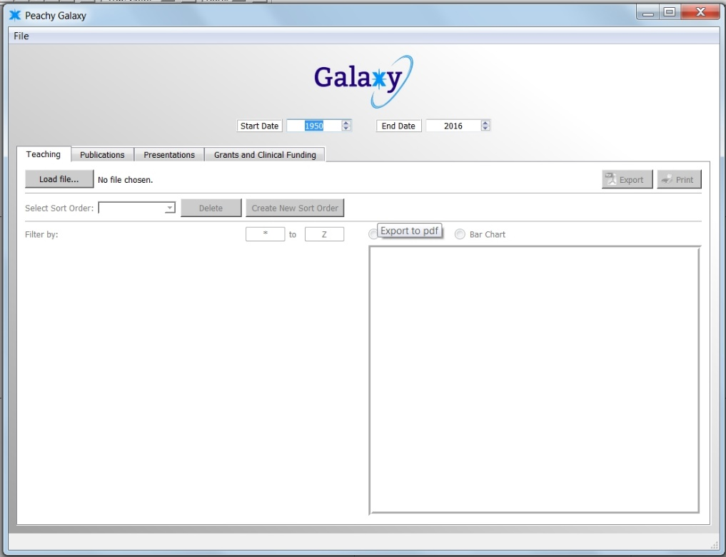

Data Loading:

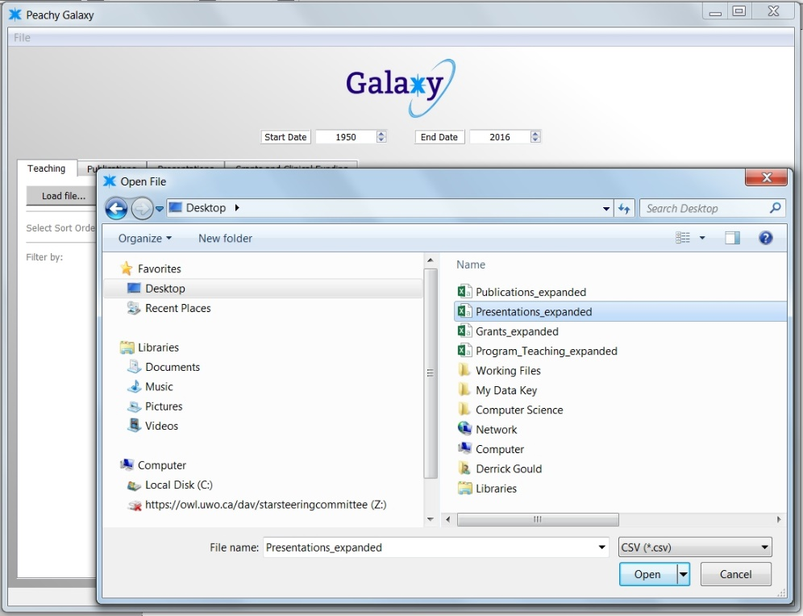

Reporting:

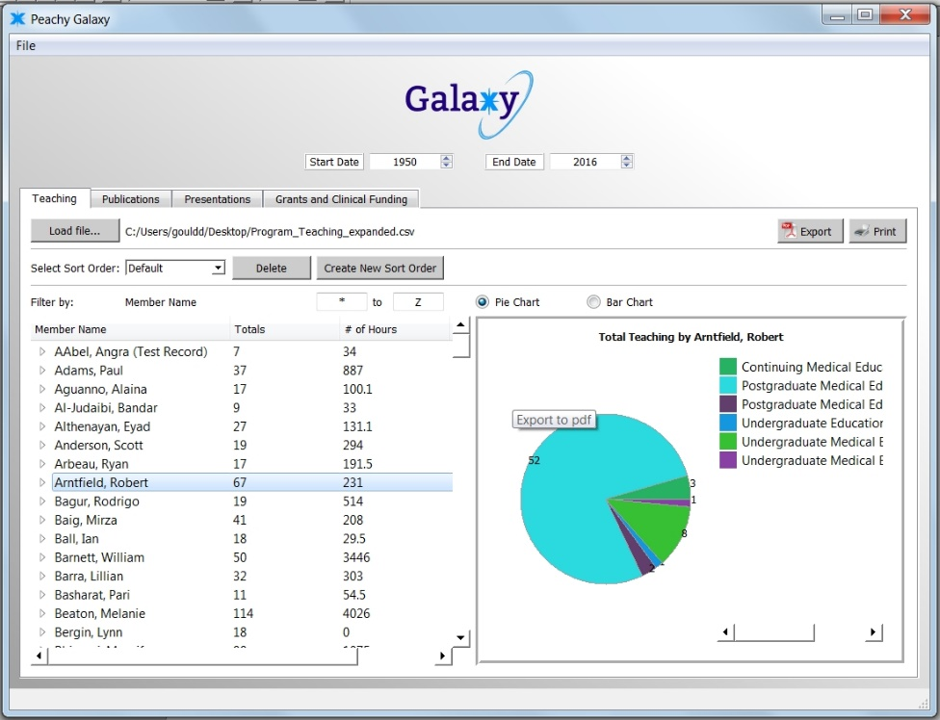

Error:

